Rajesh Vedak appointed Managing Director at
Werum IT Solutions India
News Release

Lüneburg, Germany / Mumbai, India, 19 November 2019 – Rajesh Vedak has been appointed Managing Director of Werum IT Solutions India Private Ltd. In his new role, he will oversee all business development activities and operations in India. He will be actively involved in strategic planning to further expand Werum India and strengthen the company's position on the local market.

"Rajesh Vedak was instrumental in streamlining our business offering in India over the last few years," says Jens Woehlbier, CEO of Werum IT Solutions GmbH. "We are in an exciting phase of expanding our infrastructure and operations in India. With an aligned setup and with Rajesh as our new Managing Director India, we can further improve our support for the Indian pharmaceutical and biopharmaceutical manufacturers. I wish him great success in his new position."

Rajesh Vedak looks back on more than 20 years of experience in the Indian life sciences industry. In 2016, he joined Werum as Country Manager India. In this role, he has created a strong foundation for a sustainable long-term support structure to offer Werum's best-in-class manufacturing IT solutions to regional pharmaceutical and biopharmaceutical manufacturers. Previously, he had held different functional and managerial positions at various solution providers supporting biopharma manufacturers in India. Moreover, he had worked at Merck Millipore.

Picture
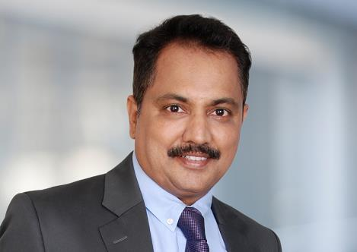
Rajesh Vedak, new Managing Director of Werum IT Solutions India Private Ltd.

About Werum IT Solutions
Werum IT Solutions is the world’s leading supplier of manufacturing execution systems (MES) and manufacturing IT solutions for the pharmaceutical and biopharmaceutical industries. Its PAS-X software product is run by the majority of the world’s top 30 pharmaceutical and biotech companies and also by many mid-sized manufacturers. Werum’s manufacturing IT solutions help pharma manufacturers to increase efficiency, improve productivity, and meet regulatory requirements. Founded in 1969, Werum is headquartered in Lüneburg, Germany, and has many locations in Europe, America, and Asia.
www.werum.com

Werum is part of Medipak Systems, the Pharma Systems business area of Körber. The Körber Group is an international technology group with around 10,000 employees all over the world. It unites technologically leading companies with more than 100 production, service and sales locations and offers its customers solutions, products and services in the Business Areas of Körber Digital, Logistics Systems, Pharma Systems, Tissue and Tobacco. The Business Area Pharma Systems provides high quality solutions for the production, inspection and packaging of pharmaceutical products and unites seven internationally successful companies under one roof.
www.medipak-systems.com, www.koerber.com

Contact:
Dirk Ebbecke
Director Corporate Communications
Werum IT Solutions GmbH
Wulf-Werum-Str. 3
21337 Lüneburg, Germany
Tel. +49 4131 8900-689
Fax +49 4131 8900-200
dirk.ebbecke@werum.com

