Sharp Packaging: Leading contract packager selects Werum IT Solutions as strategic MES partner
News Release

Manufacturing Execution System (MES) as differentiator to digitize operations and improve business opportunities / PAS-X compatibility and a shared customer base key decisive factors / First implementation in Dutch packaging facility
Lüneburg, Germany, 14 June 2018 – Following a global bidding process, Sharp Packaging selected Werum IT Solutions as its strategic MES partner to implement an Electronic Batch Record (EBR) infrastructure at its Netherlands facility.

“We see MES as a strategic system that gives us competitive advantages,” says John Hoey, Sharp IT Business Partner. “Investment in EBR will serve to improve our business opportunity pipeline and digitally transform the way in which the batch record process is executed. We have chosen Werum’s PAS-X MES because of its proven ability to handle the most complex batch records without significant configuration as well as it’s track record with a number of Sharp’s existing customers.”

By using Werum’s PAS-X MES, Sharp Packaging will benefit from greater compliance adherence, improved right first time and process standardization. The company starts its MES journey with the rollout of PAS-X at its production site in Heerenveen, the Netherlands. PAS-X fully integrates the existing Navision ERP system.

Photos:
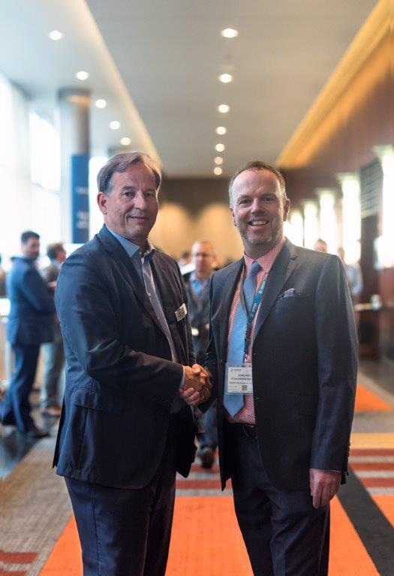
Rüdiger Schlierenkämper, CEO Werum IT Solutions, and John Hoey, Sharp IT Business Partner, closing the agreement

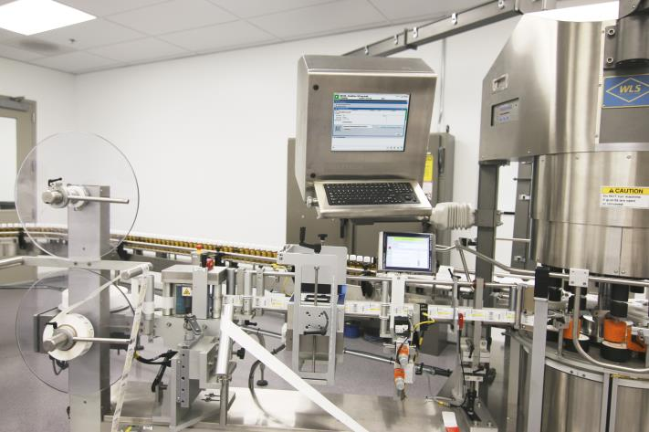
Production room at Sharp Packaging © Sharp Packaging

About Werum IT Solutions
Werum IT Solutions is the world’s leading supplier of manufacturing execution systems (MES) and manufacturing IT solutions for the pharmaceutical and biopharmaceutical industries. Its PAS-X software product is run by the majority of the world’s top 30 pharmaceutical and biotech companies but also by many mid-sized manufacturers. Werum’s manufacturing IT solutions help pharma manufacturers to increase efficiency, improve productivity, and meet regulatory requirements. Founded in 1969, Werum is headquartered in Lüneburg, Germany, and has many locations in Europe, America, and Asia.
www.werum.com

Werum is part of Medipak Systems, the Pharma Systems business area of the international technology group Körber. The Business Area’s companies, Dividella, Fargo Automation, Mediseal, Rondo, Seidenader Maschinenbau, Systec & Services and Werum IT Solutions, are global leading providers of high-quality solutions for the manufacturing and packaging process of pharmaceutical products. As a Medipak Systems company, Werum provides integrated IT solutions for all phases of pharmaceutical and biopharmaceutical production – including process development, commercial production, and packaging as well as track & trace serialization. Körber unites around 11,500 professionals in industry-leading companies worldwide, achieving annual earnings of 2.3 billion Euros.
www.medipak-systems.com, www.koerber.de/en

Contact:
Dirk Ebbecke
Director Corporate Communications
Werum IT Solutions GmbH
Wulf-Werum-Str. 3
21337 Lüneburg, Germany
Tel. +49 4131 8900-689
Fax +49 4131 8900-200
dirk.ebbecke@werum.com

About Sharp Packaging Services
Sharp, a division of UDG healthcare, is a global leader in contract packaging and clinical services. Operating from state-of-the-art facilities across the US and Europe, Sharp has built an international reputation for delivering cost-effective blister packaging, bottling, pouches and stick packs, compliance packaging, formulation and manufacturing services, label design and printing. Sharp is also a world leader in ’Track and Trace’ serialization services, which will require all prescription drugs to have a unique serial code for authentication and traceability.

For more information on Sharp and our solutions, visit www.sharpservices.com or follow us on LinkedIn, and Twitter.

Contact:
Alison Dillon
Marketing Communications Manager
Sharp Packaging Services
Tel. +353-87-146-8522
alison.dillon@sharpserviceseu.com

