MES design and implementation support:
SpiraTec and Werum IT Solutions enter service partnership
News Release

Life-science customers benefit from scalable and supplementary services during MES design and implementation of their PAS-X MES / SpiraTec becomes “PAS-X Endorsed Service Partner” for DACH region and Europe
Lüneburg / Speyer, Germany, 12 February 2020 – Werum IT Solutions and SpiraTec further extend their range of services: SpiraTec has been successfully certified as “PAS-X Endorsed Service Partner” for DACH region and Europe. This qualifies SpiraTec to support pharma and biotech manufacturers during the design and implementation phase of Werum’s Manufacturing Execution System (MES) PAS-X at production sites all over Europe. SpiraTec is a leading industrial engineering and solution specialist for information technologies and process automation with headquarters in Speyer, Germany.

“With the help of SpiraTec, we can support our customers in Europe and especially in the DACH region even more effectively,” Torsten Isenberg, Senior Director Services at Werum IT Solutions GmbH, is pleased to announce. “As PAS-X Endorsed Service Partner, SpiraTec complements our offering with services and solutions for process automation (Batch, DCS, SCADA, PLC), MBR design as well as ERP integration and takes on typical, easily scalable implementation services such as automation integration into MBR, on-site go-live support, and long-term onsite customer support.”

“We are looking forward to our partnership with Werum IT Solutions in order to join forces and combine know-how and experience on all levels for our life-science customers. Especially in the DACH region, SpiraTec will deliver optimal local support on plant production for MES and DCS with its 17 subsidiaries in Germany and Austria,” says Andreas Schadt, CEO at SpiraTec.

“ Our customers will benefit from the joint knowledge in the course of complex project tasks such as system integration of ERP to MES and DCS with synergies for MBR design, based on our know-how for Batch and DCS,” adds Michael Henter, Regional Manager Industrial IT Solutions at SpiraTec.

PAS-X Endorsed Service Partners meet all requirements of Werum IT Solutions' PAS-X service partner program. The main objective of the program is to offer the same quality and competence of services to Werum customers all over the world – through reliable, experienced and certified partners. Werum’s service partners need to have comprehensive PAS-X knowledge, participate at PAS-X trainings on a regular basis, possess experience in the regulated industries and use a quality management system. The certification has to be renewed on a regular basis.

Picture:
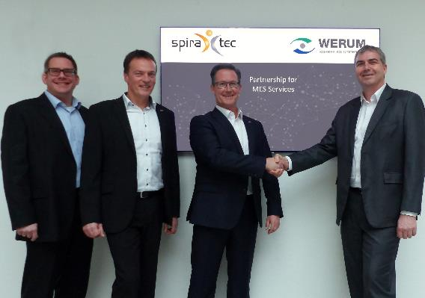
From left: Nicolas Teska (Team and Account Manager, SpiraTec), Michael Henter (Regional Manager Industrial IT Solutions, SpiraTec), Andreas Schadt (CEO, SpiraTec), Torsten Isenberg (Senior Director Services, Werum IT Solutions)

About Werum IT Solutions
Werum IT Solutions is the world’s leading supplier of manufacturing execution systems (MES) and manufacturing IT solutions for the pharmaceutical and biopharmaceutical industries. Its PAS-X software product is run by the majority of the world’s top 30 pharmaceutical and biotech companies but also by many mid-sized manufacturers. Werum’s manufacturing IT solutions help pharma manufacturers to increase efficiency, improve productivity, and meet regulatory requirements. Founded in 1969, Werum is headquartered in Lüneburg, Germany, and has many locations in Europe, America, and Asia.
www.werum.com

Werum is part of Medipak Systems, the Pharma Systems business area of the international technology group Körber. The Business Areas six companies, Dividella, Fargo Automation, Mediseal, Rondo, Seidenader Maschinenbau and Werum IT Solutions, are global leading providers of high-quality solutions for the manufacturing and packaging process of pharmaceutical products. As a Medipak Systems company, Werum provides integrated IT solutions for all phases of pharmaceutical and biopharmaceutical production – including process development, commercial production, and packaging as well as track & trace serialization. Körber unites around 11,500 professionals in industry-leading companies worldwide, achieving annual earnings of 2.3 billion Euros.
www.medipak-systems.com, www.koerber.de/en

Contact:
Dirk Ebbecke
Head of Global Marketing & Communications
Werum IT Solutions GmbH
Wulf-Werum-Str. 3
21337 Lüneburg, Germany
Tel. +49 4131 8900-689
Fax +49 4131 8900-200
dirk.ebbecke@werum.com

About SpiraTec
SpiraTec AG is a globally operating company for industrial engineering and solutions in the process industry with core competencies in the areas of digitalization, industrial engineering, industrial automation and industrial IT. At 17 locations in Germany with headquarters in Speyer (Germany), Austria and the USA, SpiraTec employs over 300 people. Its customers include well-known companies in the pharmaceutical, chemical and petrochemical industries.
www.spiratec.com

Contact:
Nicolas Teska
Team and Account Manager Industrial IT Solutions
SpiraTec AG
An der Hofweide 7
67346 Speyer, Germany
Tel. +49 6232 91906128
Nicolas.teska@spiratec.com

