Takeda Ireland introduces digital pharma operations
News Release

Go-live of Werum’s PAS-X MES at Takeda’s API production site in Grange Castle, Ireland / Successful transformation to paperless factory / Huge benefits in quality, regulatory compliance, operations and data availability / PAS-X SAP interfaces for seamless data exchange
Lüneburg, Germany, 20 August 2019 – Takeda Ireland Limited has implemented Werum’s PAS-X Manufacturing Execution System (MES) in a phased approach at its Grange Castle, Ireland, production site. Takeda is a global, research and development-driven pharma company focusing on oncology, gastroenterology and neuroscience therapeutic areas plus vaccines.

“With the help of Werum’s PAS-X MES we were able to successfully transform our Grange Castle site into a paperless factory,” says Paul Keogh, Plant Director at Takeda Ireland Limited Grange Castle. “The new digital operations provide huge quality, regulatory, operational, and data availability benefits. Example benefits include work standardization, human error avoidance, data entry reduction, batch review by exception, manufacturing decision support, material management, data visualization, etc. Moreover, the MES-based Level 2-4 integration architecture provides a solid platform for digital innovation and operational expansion.”

Werum’s PAS-X MES automatically pulls manufacturing data from the shop floor by integrating Takeda’s Process Control System via OSIsoft PI Historian. Thus, approximately 94% of all parameters in each batch record are automatically entered to the batch record. MES is configured to download recipes to the process control layer and to synchronize Electronic Batch Recording (EBR) with process controls in real-time to ensure batch data entry is contemporaneous and original as production progresses. In addition to the basic data integrity benefits, PAS-X EBR enforces additional operator confirmations and electronic signatures where required based on GxP and safety risks. Through EBR the manufacturing process is highly standardized, and batch review by exception is supported.

In addition to the shop floor integration, new PAS-X SAP interfaces were developed during the Takeda Ireland project as part of a global SAP template rollout across Takeda. These interfaces enable a seamless exchange between the global supply chain and the local manufacturing execution process.

The integrated MES template provides a basis for MES expansion to support operations for two new innovative manufacturing plants currently under construction at the Takeda Ireland Grange Castle campus. The new plants are solid oral dose and liquid vial based drug products employing high containment and cell culture technologies respectively.

Picture
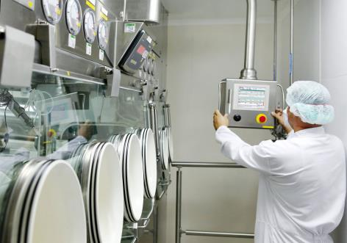
PAS-X operator

About Werum IT Solutions
Werum IT Solutions is the world’s leading supplier of manufacturing execution systems (MES) and manufacturing IT solutions for the pharmaceutical and biopharmaceutical industries. Its PAS-X software product is run by the majority of the world’s top 30 pharmaceutical and biotech companies and also by many mid-sized manufacturers. Werum’s manufacturing IT solutions help pharma manufacturers to increase efficiency, improve productivity, and meet regulatory requirements. Founded in 1969, Werum is headquartered in Lüneburg, Germany, and has many locations in Europe, America, and Asia.
www.werum.com

Werum is part of Medipak Systems, the Pharma Systems business area of the international technology group Körber. The Körber Group is an international technology group with around 10,000 employees all over the world. It unites technologically leading companies with more than 100 production, service and sales locations and offers its customers solutions, products and services in the Business Areas of Körber Digital, Logistics Systems, Pharma Systems, Tissue and Tobacco. The Business Area Pharma Systems provides high quality solutions for the production, inspection and packaging of pharmaceutical products and unites seven internationally successful companies under one roof.
www.medipak-systems.com, www.koerber.com

Contact:
Dirk Ebbecke
Director Corporate Communications
Werum IT Solutions GmbH
Wulf-Werum-Str. 3
21337 Lüneburg, Germany
Tel. +49 4131 8900-689
Fax +49 4131 8900-200
dirk.ebbecke@werum.com

