Teerapong Cheepchol appointed as Managing Director at Werum IT Solutions Thailand
News Release

Lüneburg, Germany / Bangkok, Thailand, 30 October 2019 – On 1 October 2019, Teerapong Cheepchol (Jack) assumed his new position as Managing Director of Werum IT Solutions Ltd., Thailand. He succeeds David Margetts.

Teerapong Cheepchol looks back on more than twelve years of experience in the pharma industry and Manufacturing Execution System (MES) business. In his previous role, he served as Deputy Managing Director and Operations Director of Werum IT Solutions Ltd., Thailand, where he was responsible for service delivery and business administration since the opening of Werum's Asian hub in 2016. He had an active role in overseeing the company's overall business operations. Moreover, Teerapong Cheepchol was involved in strategic planning and organizing the company's activities to achieve its goals while building a strong team in Asia to provide high-quality service to its customers.

"We are very excited to have Teerapong Cheepchol taking on the role of Werum Asia’s Managing Director," says Jens Woehlbier, CEO of Werum IT Solutions GmbH. "He is best suited to guide and expand our business in the APAC region. Under Teerapong's dedicated leadership, Werum Asia will further develop the local team and strengthen existing relationships with its customers and partners. We wish Teerapong great success in his new position."

At the same time, Jens Woehlbier thanked David Margetts for successfully managing Werum Asia: "David Margetts has done a great job in expanding our Asian business. We wish him and his family all the best in their future endeavors."

Picture
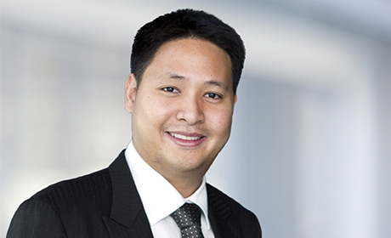
Teerapong Cheepchol (Jack), new Managing Director of Werum IT Solutions Ltd., Thailand

About Werum IT Solutions
Werum IT Solutions is the world’s leading supplier of manufacturing execution systems (MES) and manufacturing IT solutions for the pharmaceutical and biopharmaceutical industries. Its PAS-X software product is run by the majority of the world’s top 30 pharmaceutical and biotech companies and also by many mid-sized manufacturers. Werum’s manufacturing IT solutions help pharma manufacturers to increase efficiency, improve productivity, and meet regulatory requirements. Founded in 1969, Werum is headquartered in Lüneburg, Germany, and has many locations in Europe, America, and Asia.
www.werum.com

Werum is part of Medipak Systems, the Pharma Systems business area of Körber. The Körber Group is an international technology group with around 10,000 employees all over the world. It unites technologically leading companies with more than 100 production, service and sales locations and offers its customers solutions, products and services in the Business Areas of Körber Digital, Logistics Systems, Pharma Systems, Tissue and Tobacco. The Business Area Pharma Systems provides high quality solutions for the production, inspection and packaging of pharmaceutical products and unites seven internationally successful companies under one roof.
www.medipak-systems.com, www.koerber.com

Contact:
Dirk Ebbecke
Director Corporate Communications
Werum IT Solutions GmbH
Wulf-Werum-Str. 3
21337 Lüneburg, Germany
Tel. +49 4131 8900-689
Fax +49 4131 8900-200
dirk.ebbecke@werum.com

