News Release

Shanghai Wellthinic Technology certified as new “PAS-X Endorsed Service Partner Local” for the support of MES/automation implementation in People’s Republic of China
Werum IT Solutions and Chinese-based Shanghai Wellthinic Technology signed a partnership agreement to benefit from complementing PAS-X MES implementation by delivering and integrating automation systems such as SCADA or DCS as well as additional resources during PAS-X implementation projects
Shanghai, People’s Republic of China, 29 October 2018 – Good news for pharma and biotech manufacturers in China: Werum IT Solutions further expands and complements its PAS-X Service Partner network. The world’s leading supplier of manufacturing execution systems (MES) signed a partnership agreement with Shanghai Wellthinic Technology. Based in Shanghai with several local offices in China, Shanghai Wellthinic Technology is a leading IT solutions provider to the Chinese life science industry with focus on automation systems and MES.

As a certified “PAS-X Endorsed Service Partner Local”, Shanghai Wellthinic Technology will support Werum customers in the People’s Republic of China with the on-site-implementation of Werum's PAS-X MES and automation systems. For instance, Wellthinic will provide resources for project management, MBR design, system configuration, installation, training as well as the implementation and integration of automation and equipment.

“We selected Wellthinic amongst many candidates based on their years of experience in the life sciences industry and because of their complementary capabilities on ISA-Level 2 systems” says Torsten Isenberg, Senior Director Services at Werum IT Solutions. “Wellthinic has an excellent reputation in China and successfully managed a wide range of services – from single-site projects up to large roll-outs. Furthermore, Wellthinic’s management has been working with foreign companies for decades hence being able to greatly bridge our cultural differences. Therefore, Wellthinic will provide our pharma and biotech customers with high-quality services and support for the years to come.”

Paul Dong, CEO of Shanghai Wellthinic Technology: “Wellthinic’s long experience in offering IT solutions to the pharmaceutical market offers Werum and its customers a stable and reliable partner for the implementation of PAS-X MES. With our deep understanding of the daily operations in the industry, we can perform the transition from a paper-based to a digital-based quality control system more efficiently and in high quality.”

PAS-X Endorsed Service Partners meet all requirements of Werum's PAS-X Service Partner Program. The main objective is to offer the same quality and competence of services to Werum customers all over the world – through reliable, experienced and certified partners. The Service Partners need to have comprehensive PAS-X knowledge, participate at PAS-X trainings on a regular basis, possess experience in the regulated industry and use a quality management system. The certification has to be renewed on a regular basis.

Photo:
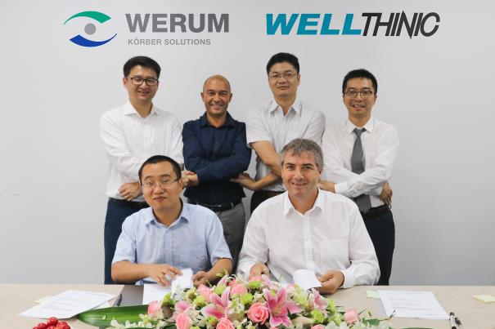
At the closing of the agreement (from left): Yun Fan (KMS China), Paul Dong (Wellthinic), Olivier Néron (Werum), Matii Yan (Wellthinic), Torsten Isenberg (Werum) and Dong Wang (KMS China, Werum)
About Werum IT Solutions
Werum IT Solutions is the world’s leading supplier of manufacturing execution systems (MES) and manufacturing IT solutions for the pharmaceutical and biopharmaceutical industries. Its PAS-X software product is run by the majority of the world’s top 30 pharmaceutical and biotech companies and also by many mid-sized manufacturers. Werum’s manufacturing IT solutions help pharma manufacturers to increase efficiency, improve productivity, and meet regulatory requirements. Founded in 1969, Werum is headquartered in Lüneburg, Germany, and has many locations in Europe, America, and Asia.
www.werum.com

Werum is part of Medipak Systems, the Pharma Systems business area of the international technology group Körber. The Business Area’s companies, Dividella, Fargo Automation, Mediseal, Rondo, Seidenader Maschinenbau, Systec & Services, Traxeed and Werum IT Solutions, are global leading providers of high-quality solutions for the manufacturing and packaging process of pharmaceutical products. As a Medipak Systems company, Werum provides integrated IT solutions for all phases of pharmaceutical and biopharmaceutical production – including process development, commercial production, and packaging as well as track & trace serialization. Körber unites around 12,000 professionals in industry-leading companies worldwide, achieving annual earnings of 2.6 billion Euros.
www.medipak-systems.com, www.koerber.de/en

Contact:
Dirk Ebbecke
Director Corporate Communications
Werum IT Solutions GmbH
Wulf-Werum-Str. 3
21337 Lüneburg, Germany
Tel. +49 4131 8900-689
Fax +49 4131 8900-200
dirk.ebbecke@werum.com

About Shanghai Wellthinic Technology
Shanghai Wellthinic Technology is a professional engineering company in the field of automation and digital plant solutions. Wellthinic provides fully integrated solutions to its clients with turn-key engineering including the supply and configuration of field instrumentation, PLCs, DCSs, MES, LIMS and APS. Thanks to high quality specialist engineers with international project experience, the company provides a capable and diverse knowledge base, supplemented with excellent procedures. Wellthinic currently focuses on specific requirements of local clients in the Chinese market, providing a complete life cycle service in the pharmaceutical, bio-pharmaceutical, CPG (consumer product goods) and fine chemical industry – from conceptual design and project engineering through to production optimization, upgrades and maintenance.
www.wellthinic.com

Contact:
Paul Dong
Shanghai Wellthinic Technology
6-128/130/132R, 787#, Kangqiao Road
Shanghai, 201315, P. R. China
7876 128-132
Tel. +86 21 6190-0676
Fax +86 21 6190-0679
marketing@wellthinic.com

