MES project excellence & implementation support:
prime4services and Werum IT Solutions enter service partnership
News Release

Customers benefit from independent consulting and experience in the field of MES, Track & Trace and OEE implementation / Scalable and supplementary services to support PAS-X MES implementation / "PAS-X Endorsed Service Partner" for Europe
Lüneburg, Germany, 4 June 2019 – Werum IT Solutions further extends its range of services: prime4services has been successfully certified as "PAS-X Endorsed Service Partner" for Europe. This qualifies prime4services to support pharma and biotech manufacturers during the implementation phase of Werum's PAS-X Manufacturing Execution System (MES) at production sites in the DACH region and Italy. prime4services is a service provider for independent consulting, engineering & IT services to optimize both quality and efficiency and to drive manufacturing excellence at the customer's site.

"prime4services helps us further improve and expand support services for our European customers, in particular in Italy," Torsten Isenberg, Senior Director Services at Werum IT Solutions GmbH, is pleased to announce. "As PAS-X Endorsed Service Partner, prime4services provides independent consultancy services – typically at the customer's – and thus enhances Werum's service portfolio for our common customer base in a seamless way."

"By combining Werum's and prime4services's expertise, our customers will benefit from the long-term, complementary experience of our two companies. This partnership is a landmark and future-oriented decision for prime4services and Werum. We look forward to an exciting cooperation," says Yasmine Peters, Managing Director at prime4services.

PAS-X Endorsed Service Partners meet all requirements of Werum IT Solutions' PAS-X service partner program. The main objective of our program is to offer the same quality and competence of services to Werum customers all over the world – through reliable, experienced and certified partners. Our service partners need to have comprehensive PAS-X knowledge, participate at PAS-X trainings on a regular basis, possess experience in the regulated industries and use a quality management system. The certification has to be renewed on a regular basis.

Picture
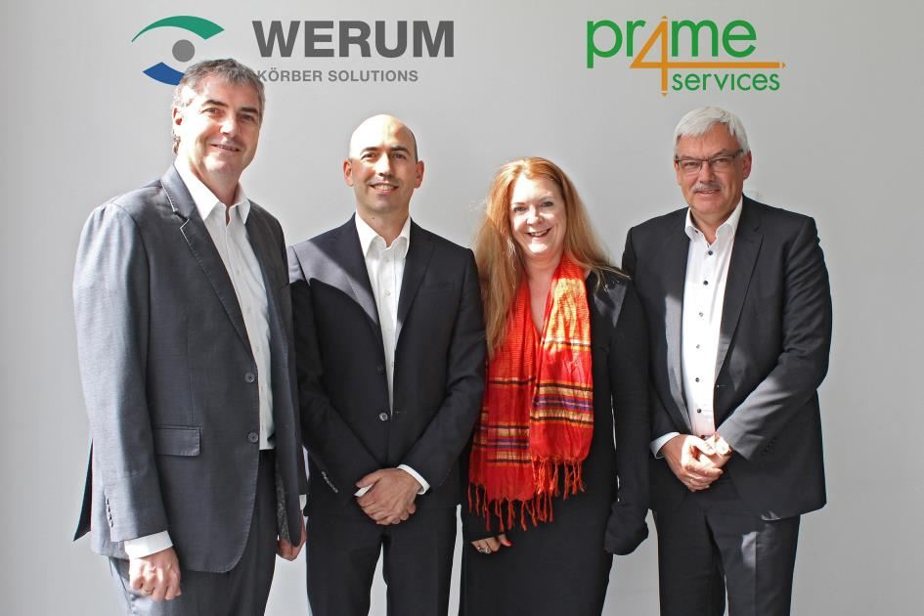
From left: Torsten Isenberg (Werum IT Solutions), Nicola Catania & Yasmine Peters (prime4services), Reiner Kühl (Werum IT Solutions)

About Werum IT Solutions
Werum IT Solutions is the world’s leading supplier of manufacturing execution systems (MES) and manufacturing IT solutions for the pharmaceutical and biopharmaceutical industries. Its PAS-X software product is run by the majority of the world’s top 30 pharmaceutical and biotech companies but also by many mid-sized manufacturers. Werum’s manufacturing IT solutions help pharma manufacturers to increase efficiency, improve productivity, and meet regulatory requirements. Founded in 1969, Werum is headquartered in Lüneburg, Germany, and has many locations in Europe, America, and Asia.
www.werum.com

Werum is part of Medipak Systems, the Pharma Systems business area of the international technology group Körber. The Business Area’s companies, Dividella, Fargo Automation, Mediseal, Rondo, Seidenader Maschinenbau, Systec & Services, Traxeed and Werum IT Solutions, are global leading providers of high-quality solutions for the manufacturing and packaging process of pharmaceutical products. As a Medipak Systems company, Werum provides integrated IT solutions for all phases of pharmaceutical and biopharmaceutical production – including process development, commercial production, and packaging as well as track & trace serialization. Körber unites around 10,000 professionals in industry-leading companies worldwide, achieving annual earnings of 2.6 billion Euros.
www.medipak-systems.com, www.koerber.de/en

Contact:
Dirk Ebbecke
Director Corporate Communications
Werum IT Solutions GmbH
Wulf-Werum-Str. 3
21337 Lüneburg, Germany
Tel. +49 4131 8900-689
Fax +49 4131 8900-20
dirk.ebbecke@werum.com

About prime4services group
prime4services is a global consulting and engineering services provider with offices across Europe and Asia. Since 2009, we have been successfully supporting the life science industry and have worked with many of the Fortune Global 500 companies. We are actively engaging with our life science industry clients on the journey to their next milestone towards Industry 4.0. Our team consists of 40+ experts specializing in MES, T&T, OEE, LIMS, Quality & e-Compliance areas, and all are committed to ensuring customer satisfaction, innovation and successful delivery on all projects.
www.prime4services.com

Contact:
Yasmine Peters
prime4services GmbH
Rüppurrer Str. 1
76137 Karlsruhe, Germany
Tel. +49 721 60 957 888
Fax +49 721 60 957 980
yasmine.peters@prime4services.com

