Press Statement 01.04.2025
Volker Koch takes over responsibility for the packaging business of the Körber Business Area Pharma in Schloß Holte-Stukenbrock
Schloß Holte-Stukenbrock, April 1, 2025 - Körber Pharma Packaging GmbH has a new CEO as of April 1, 2025. Volker Koch, former Chief Procurement Officer of the Körber Group and Head of the Group Function Procurement & Supply Chain Management, has taken over the position of CEO from Katharina Hinz, who will assume new responsibilities within the Körber Group on April 1. Katharina Hinz has been CEO of the business in Schloß Holte-Stukenbrock since 2022 and has played a key role in shaping the specialist machine manufacturer for packaging in the pharmaceutical industry during this time. The engineer is returning to her old place of work in Hamburg, where she began her career in the Körber Group more than 20 years ago.
Volker Koch has more than 15 years of professional experience in various management positions. An economics graduate, he initially worked as a management consultant for several years before moving to responsible positions in purchasing and operations in the mechanical engineering industry. He joined the Körber Group in 2015, where he has since held various management positions in Procurement & Supply Chain Management and was also responsible for the Business Area Pharma and the Pécs campus in Hungary. He has been Head of Global Procurement for the Group since 2023.
Erich Hoch, Member of the Executive Board and operationally responsible for the Business Area Pharma at Körber, emphasizes: “Volker Koch is an outstanding Manager and we are delighted to have found a proven expert to head our innovative specialty machinery manufacturer for high-tech packaging systems. He will continue the work of Katharina Hinz and provide additional impetus to our growth course with his business expertise, strategic thinking and in-depth knowledge of the industry.” Hoch continued: “I would like to thank Katharina Hinz for her excellent work over the past few years.”
Volker Koch says: “I am delighted to be taking on this new role and to be able to work with such a dedicated team in the future. What sets us apart is an impressive history and a clear vision for the future. My goal is to further expand the high professional quality that characterizes the team in Schloß Holte-Stukenbrock and to take the innovative premium manufacturer to the next level in the coming years.”
Katharina Hinz explains: “I would like to express my sincere thanks for the trust that has been placed in me from all sides over the past few years. And I am proud of everything we have achieved together. I am convinced that the packaging experts in Schloß Holte-Stukenbrock will continue to be successful under the management of Volker Koch. I wish him and the entire team every success on this path.”

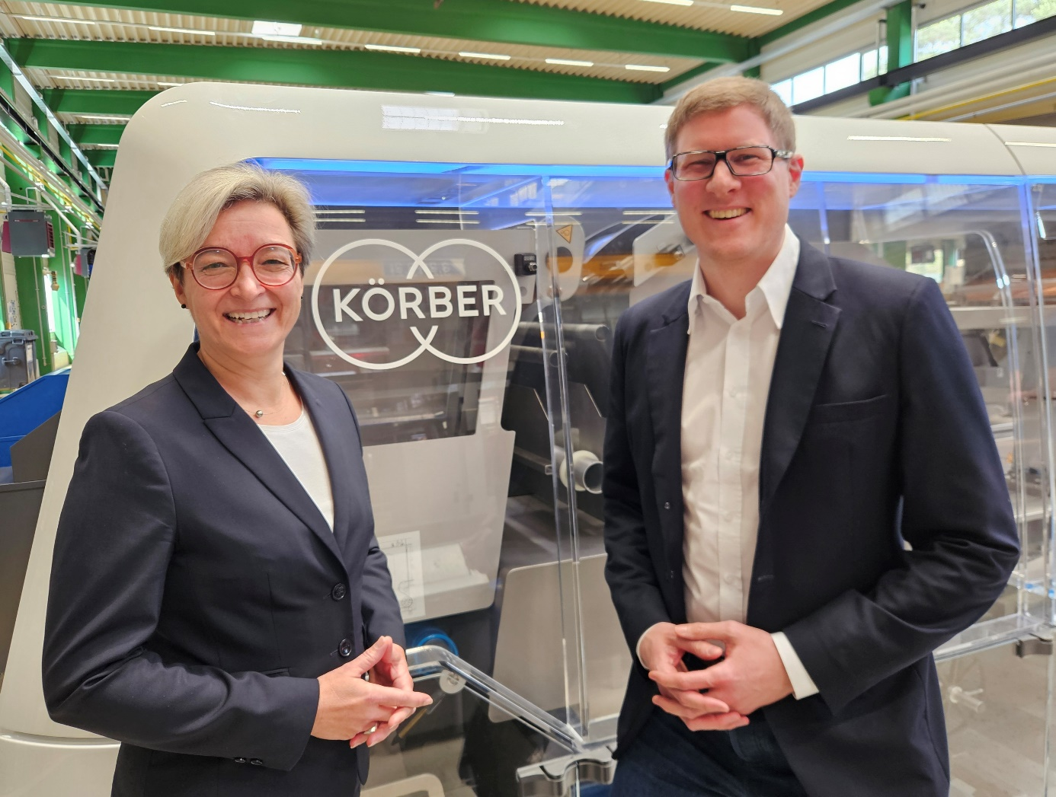
  - Photo caption: Change at the top of Körber Pharma Packaging GmbH in Schloß Holte-Stukenbrock: Volker Koch (right) takes over as the new CEO as of April 1.

About Körber AG
We are Körber - an international technology group with around 13,000 employees at over 100 locations worldwide and a common goal: We turn entrepreneurial thinking into customer success and shape technological change. In the Business Areas Digital, Pharma, Supply Chain and Technologies, we offer products, solutions and services that inspire. We respond quickly to customer needs, implement ideas seamlessly and create added value for our customers with our innovations. In doing so, we are increasingly building on ecosystems that solve the challenges of today and tomorrow. Körber AG is the holding company of the Körber Group.
About the Business Area Pharma
In the Körber Business Area Pharma, we make the difference along the entire pharma value chain by offering a unique portfolio of integrated solutions. With in-depth experience in consulting, inspection, transportation systems, packaging machines and materials, track & trace and software, we understand the challenges in pharmaceutical processes and regulation that our customers face every day. We have the right solutions for them to unlock the full potential of global pharma and biotech production.

Contact
Tanja Ehrlich
Körber Pharma
Head of Marketing Communications
Phine: +49 40 21107-01
Email: tanja.ehrlich@koerber.com

