**On course for growth: Körber expands production area for handling and packaging solutions in North America**

**The continued high demand for handling and packaging solutions offered by Körber's Business Area Pharma has made it necessary to expand the company's facilities in Fargo, North Dakota, once again A third production facility has been added ~~to~~ with the "West Campus”, only one and a half years after the first expansion.**

"With a portfolio focused on machines for handling and buffering syringes, packaging medical devices, and creating customized packaging solutions, we are meeting the needs of our pharmaceutical customers - as demonstrated by our high annual growth rates and historical order intake," said Kerry Fillmore, Chief Executive Officer (CEO) North America of Körber's Business Area Pharma. For this reason, Körber is expanding its North American site with another assembly facility, now totaling three production facilities.

Starting in October 2021, more than 1000 additional square meters will be available in the "West Campus", expanding the area for assembly of existing products by another 70%. The open space at the “North Campus” will house assembly and new prototypes for end-of-line products, which will be developed there. The "South Campus," which was inaugurated in 2020, is still the home for machining.

**Expansion plan: All production sites under one roof in the medium term**

Due to its design and structure, the expansion can happen without interrupting operations and without any customer restrictions. "At the same time, we have created the capabilities to handle the strong order intake from our customers," explains David W. Brown, Chief Operating Officer (COO) and President of the Körber site in Fargo, North Dakota. "The new “West Campus” expansion serves as an interim, short term solution. Our medium term strategic plan is to bring all production facilities in Fargo back under one roof."

To create even more space at the North American site in the short term, the Business Area Pharma is also making use of the Group's own network: " As our portfolio from the USA is also in high demand in Europe, we have relocated some production for handling and packaging solutions, which will be put into operation in Europe, from the USA to the Körber Campus in Pécs, Hungary. With this, European customers benefit from our lean supply chain," says Dr. Jürgen Krebs, Chief Operating Officer (COO) and Chief Technology Officer (CTO) in the Business Area Pharma. The production space freed up in North America will be used for further orders and product development for the local market. "In Fargo, all signs point to growth!" summarizes Krebs.

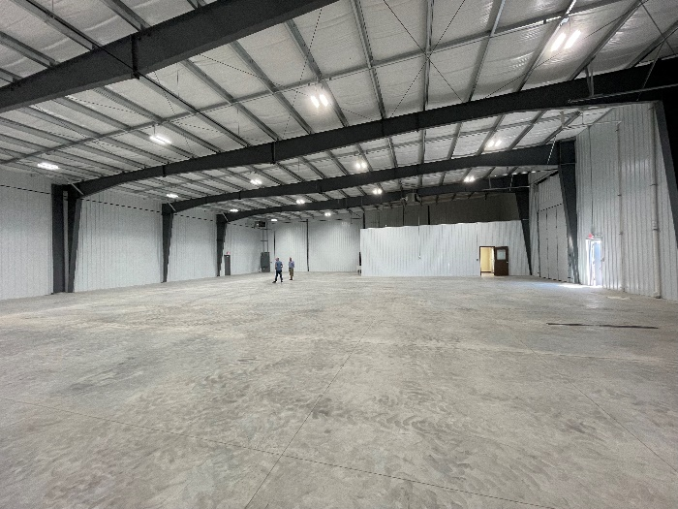

West Campus Interior: The new "West Campus" building expands the assembly area by an additional 70%.

**About Körber**

We are Körber – an international technology group with about 10,000 employees, more than 100 locations worldwide and a common goal: We turn entrepreneurial thinking into customer success and shape technological change. In our five Business Areas Digital, Pharma, Supply Chain, Tissue and Tobacco, we offer products, solutions and services that inspire. We respond quickly to customer needs, we implement ideas seamlessly, and our innovations create added value for our customers. We are increasingly building on ecosystems that solve the challenges of today and tomorrow. Körber AG is the holding company of the Körber Group. We are the home for entrepreneurs.

**About Körber’s Business Area Pharma**

At Körber Pharma, we deliver the difference along the entire pharmaceutical value chain by offering a unique portfolio of integrated solutions. Based on in-depth experience spanning consulting, inspection, transport systems, packaging machines and materials, track and trace and software, we understand the challenges in pharmaceutical processes and regulation that our customers face day to day, from the beginning to the end of their production. For them, we deliver the difference to unlock the potential of global pharmaceutical and biotech manufacturing.

**Contact:**

Diane Hunt  
Körber Business Area Pharma  
Head of Marketing North America  
M +1 973-202-8156  
[Diane.hunt@koerber-pharma.com](mailto:Diane.hunt@koerber-pharma.com)  
[koerber-pharma.com](http://www.koerber-pharma.com/)